Day 33 - 104608492 - Shirisha Perapagu
AWS DynamoDB – Day 33 - Clusters

Task 01:
Creating a DAX cluster in AWS (using Console).

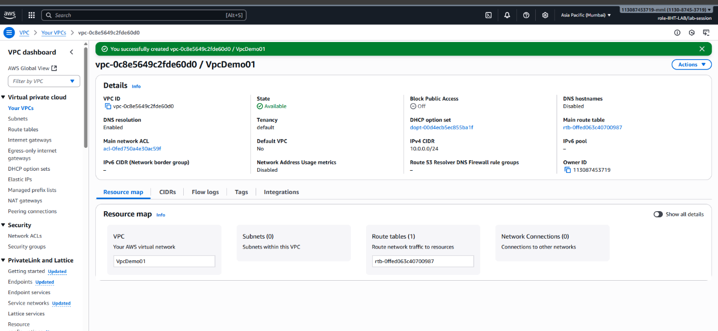

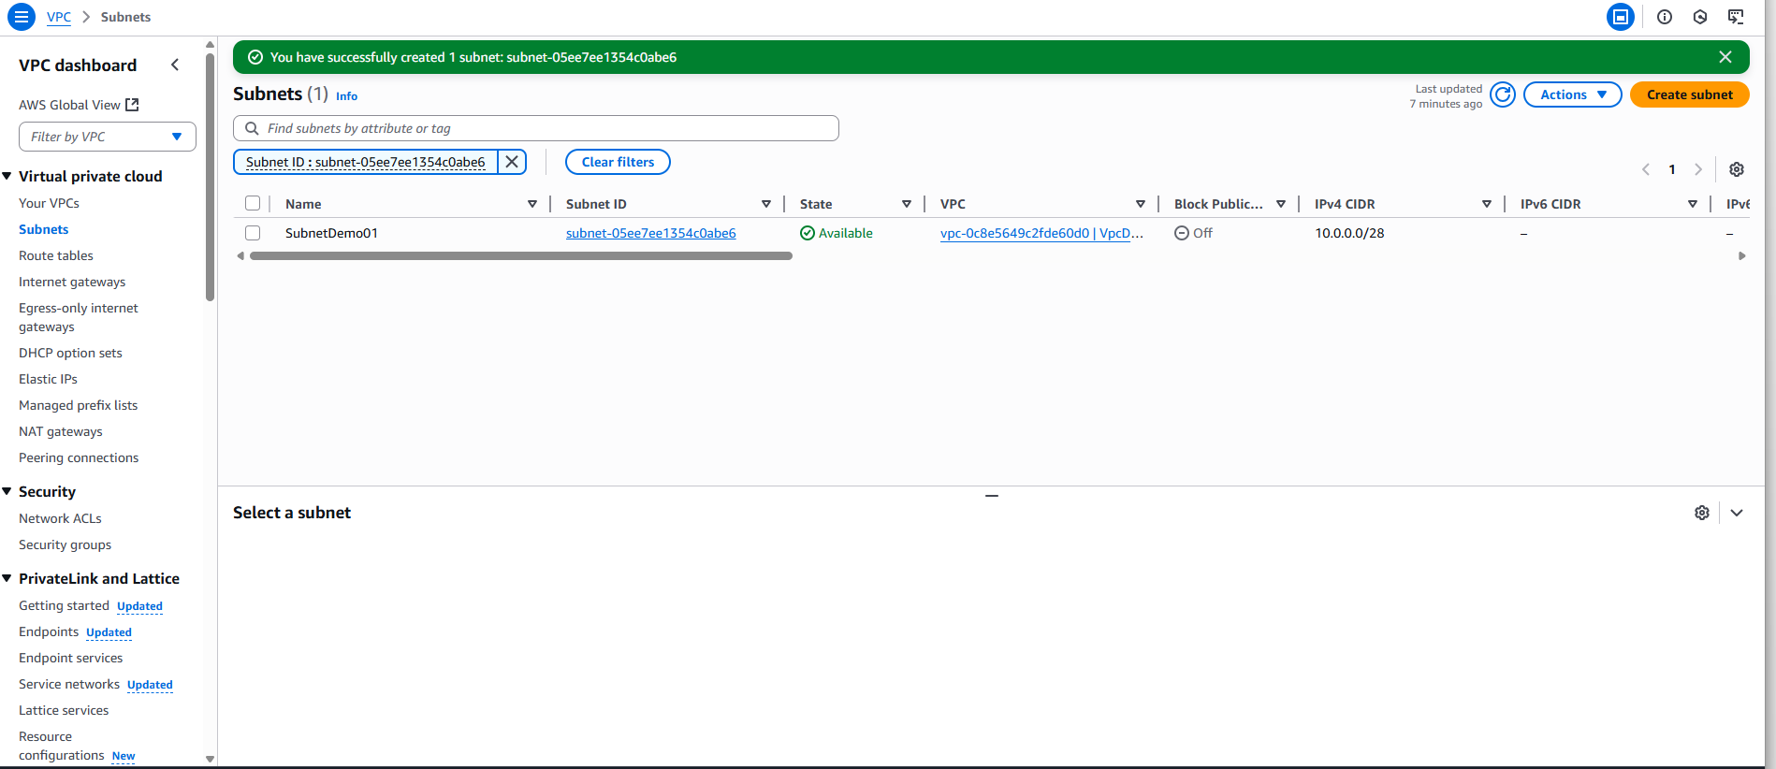

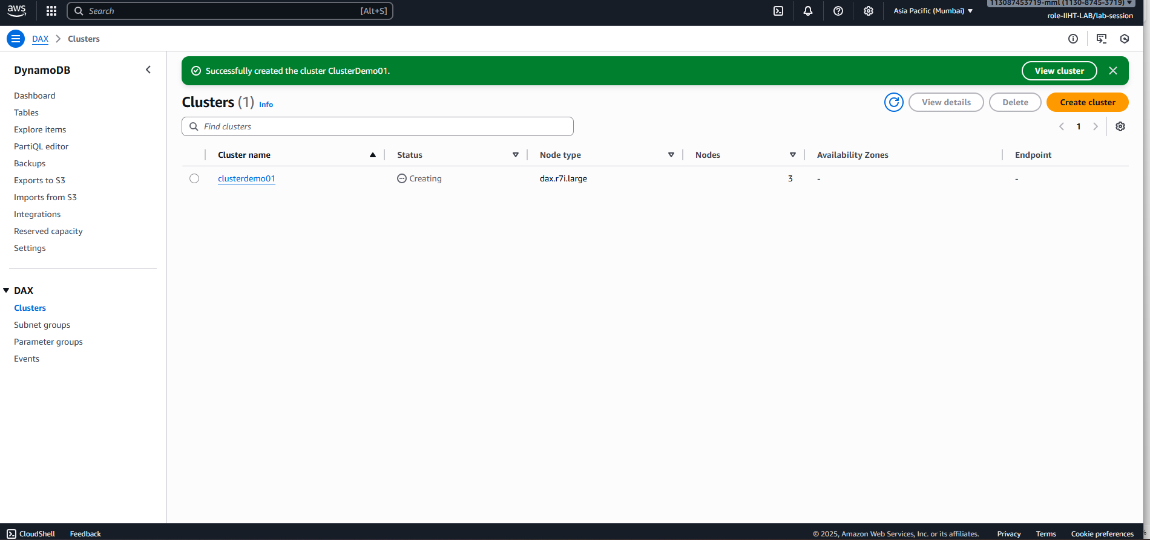

Task 02

Not working
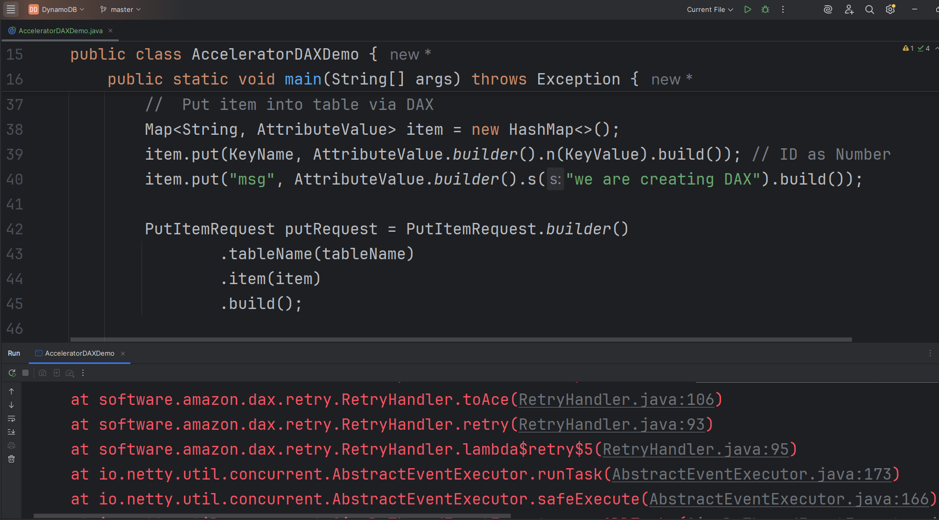

Task03
Question code is yet to be completed

Task 04
Not working

